FlightMap Guide - Registration Process

Introduction
This guide describes how you can register your Flightmap installation by using its reference number.

Content
section page
1 Reference Number 2
2 Registration Confirmation dialog 2
3 Registration Request dialog 3
4 Sample Registration Request 3
5 Registration by Email 4
6 Re-installing FlightMap 4

Reference Number
When you first install FlightMap on any PC, an installation reference number is generated for that particular PC. You can use the reference number to register your installation on that PC. Provided you have a FlightMap licence then you get, in return, a matching authorization code which you use to confirm your registration.
Your installation reference number is displayed in the About FlightMap dialog that is presented each time you start FlightMap or when you use the About FlightMap command of the Help menu.
Until you register your installation you will see reminders to do so. Each reminder appears as the Registration Confirmation dialog which is described below. The frequency of reminders increases the more that you use FlightMap.
If you install FlightMap on another PC – e.g. on your laptop – that will generate its own different installation reference number. You will therefore need to register both installations as they will have different authorization codes.

Registration Confirmation dialog
Initially, the Registration Confirmation dialog is presented after each use of the About FlightMap dialog. It is your opportunity to confirm registration by entering the authorization code for your installation. The dialog is presented more frequently if you continue to use FlightMap without confirming its registration.
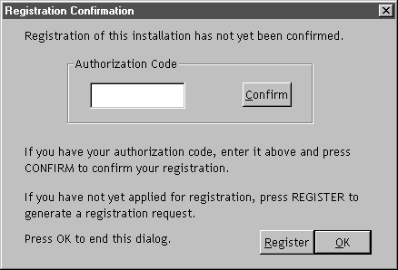
When you have your authorization code, enter it in the Authorization code dialog box and press Confirm. You will see the message “Authorization code is correct” added to the dialog. Press OK to close the dialog. The Registration Confirmation dialog will then no longer be presented.
If you have not sent your installation reference number for registration, press Register to have the Registration Request dialog presented to assist your making a registration request for sending by mail. Alternatively you may register by sending the same information as an email.

Registration Request dialog
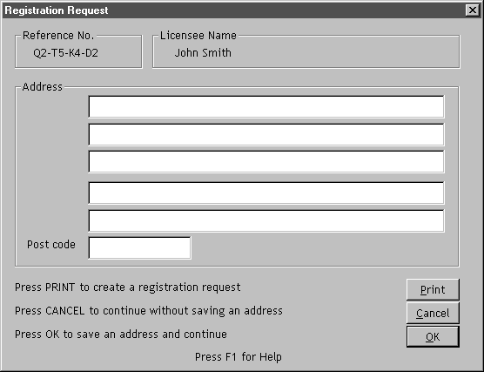
- Enter your address. If you have a printer, press Print to print a request on A4 paper. If you do not have a printer, copy from the sample below.
- Mail your registration request to the address printed on it. You will receive an authorisation code that you enter into the Registration Authorisation dialog which is presented when you next start FlightMap.
- Press Cancel to close the dialog without saving your address.
- Press OK to save your address and close the dialog.

Sample Registration Request
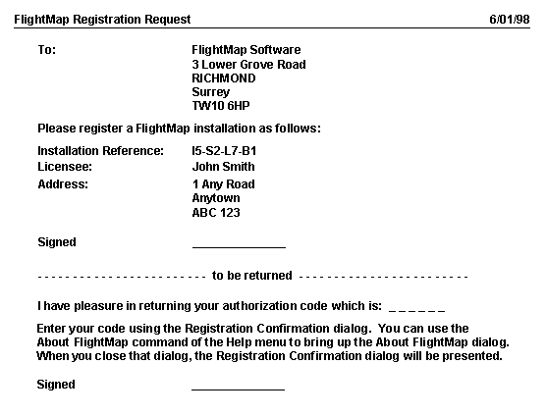

Registration by Email
You can send your registration request by email to help@flightmap.eu. Include your installation reference number and name and also your address - as that will be used to uniquely identify you as a licensee.

Re-installing FlightMap
If you have deleted FlightMap and wish to re-install it then you must run FlightMap Setup to do so. Setup is available in the compressed .zip file that you can download from the FlightMap website. For full releases – i.e. excluding Version 2.3 Beta - Setup is also available as a DVD. Refer to Chapter 1 – Getting Started of the user manual How To Use FlightMap for how to run Setup.
If you re-build your Windows registry before re-installation then Setup will generate a new installation reference number. You should then request a new authorization code as described above.

